Practicle 2:study of filter commands & Editors

Assignment1:study of filter command -1

Try the following commands with atleast three options.

Od:-

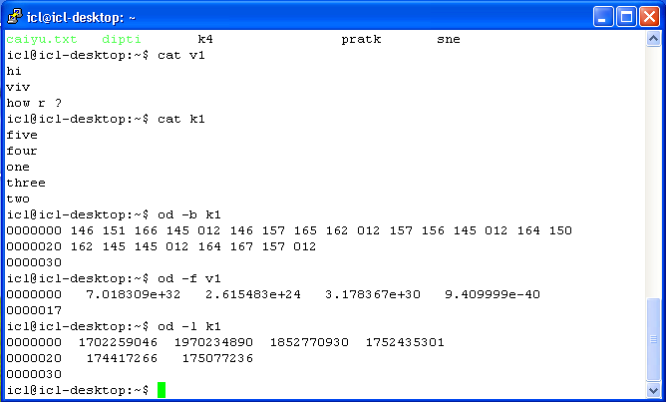

Cmp:

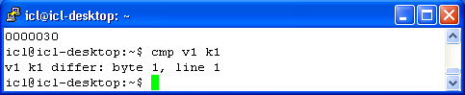

Diff :-

